**Class Test 01**

1. Display the job and the hire date of the most senior employee of each department and order the result by descending order.
2. Display today’s day and time. The format must return a result like this: Sunday 3:30:45.Label the column as Day and Time.
3. Display the name, salary and dream salary. If department is 10 dream salary will be actual salary+1000, if department is 20 dream salary will be actual salary+2000. For all other departments the dream salary will be actual salary+3000. Sort by ascending order of dream salary.
4. Find out if the year 2016 is a leap year or not.
5. Display the name and job of the employee where the employee is a manager or clerk

or analyst. You must use IN operator.

1. Display only the names of employees who have at least one M.
2. Display the name of all employees who have two *L’*s or two T’s in their name. Make sure there is no other letters in between the said letters.
3. Trim the string 00abc000 in such a way that the output is 00abc.

|  |  |
| --- | --- |
| **t_id** | Number(10) |
| **t_name** | Varchar2(20) |
| **phone** | Number(10) |
| **salary** | Number(7) |
| **email** | Varchar2(30) |

1. Create a table named **Teacher** from following structure using SQL command.

**Subquery**

1. Display the employee names who joined after KING.
2. Display the employee names that earn a salary that is higher than the salary of all CLERKS.
3. Display the employee names that earn a salary that is higher than the salary of any CLERKS.
4. Display the employee names who get the department wise highest amount of salary.
5. Display the employee names who earn more than employee SMITH.

**Joining**

1. Display the name of all the employees who work in DALLAS.
2. Display the name of all the employees who joined before their manager.
3. Display the name of all the employees and their respective manager. If an employee does not have a manger display ‘NO MANAGER’.
4. Display the salary grades of each employee.
5. Write a query to display the name, department number, and department name for  
   all employees.

**Schema Diagram**

1. Create the tables according to the schema provided below. Arrows point from foreign key to corresponding primary key. Also insert 5 rows of data into each table created.

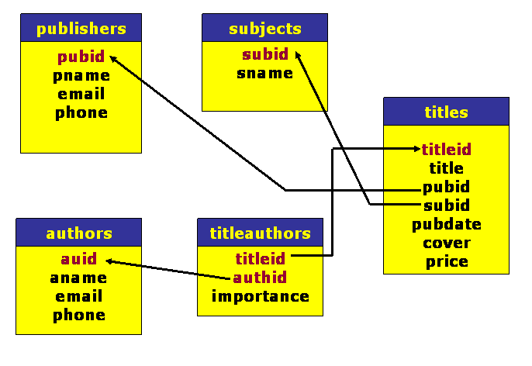

**\*\*After solving the above questions using Oracle 10g, write the SQLs in a text document (the name of the text document MUST be your ID) and upload it in the provided link in your VUES account**